**The UDP Bandmap**

Aki Yoshida JA1NLX

## Sub menu for "Appearance"

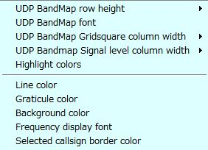

UBM_10

UDP Bandmap Gridsquare and Signal Level column width can be selected respectively.

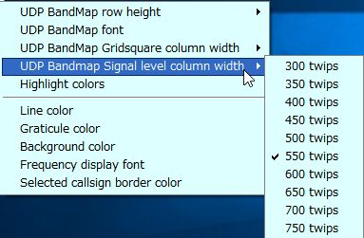

UBM_10A

~~m~~

Click "Highlight colors" to configure Gridsquare highlight colors and UDP Bandmap text color. If you prefer to see bold text for callsign who have called CQ then check "Show bold text who have called CQ"

.

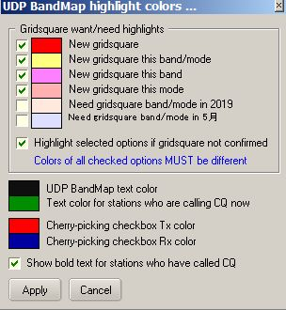

New UBM_11

Sample below.　The stations who are calling CQ now are displayed in Green text, the stations who have called CQ are displayed in Black/bold text and the stations who are working other stations are displayed in Black text.

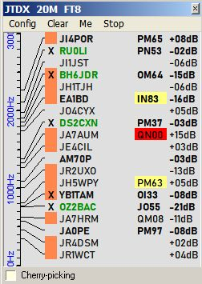

New UBM_11A

## 5.2. Clear

This clears UDP Bandmap.